QRM Review

0 < DW < 4

DW = 2 no autocorrelation

DW > 2 negative autocorrelation

DW < 2 positive autocorrelation

1.5 < Rule of thumb < 2.5: no autocorrelation

Eviews

All functions can be assessed by quick

For Augmented Dickey-Fuller test

The test’s null hypothesis is that Copper has a unit root/not stationary. It cannot be rejected as the p-value > 0.05 and indicates that the series is not stationary. (can include a constant and trend)

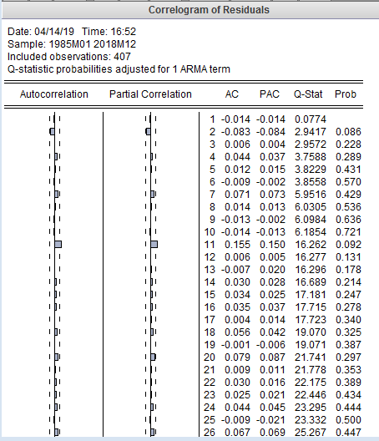

Does the correlogram suggest random residuals?

- Yes. The residuals do not have low p-values.

Are any of the Q-statistics significant?

The Box-Pierce Q-statistic is shown to the right of the ACF and PACF plots. This statistic considers autocorrelation in several lags together. The p-value of the Q-statistic is given for convenience. When testing at 5% significance, a p-value less than 5% indicates significance.

- No. Everything is above 0.05.

The best overall performing model is AR(1) AR(2). MA(1) MA(2) has slightly lower AIC and SCI, however only one of the variables is statistically significant.

The autocorrelations are not very persistent which suggests stationarity

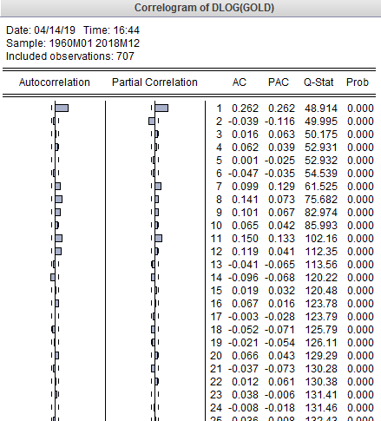

Forecast 的时候要修改时间区间